**User Manual**

This is Xaria’s icon.

Once you click on the icon, you will be greeted by Team Sunflower’s splash screen.

This is the start screen. The user has two options to choose from: start and test.

Pressing the start button starts the game. Pressing the test button tests the product and displays to the screen.

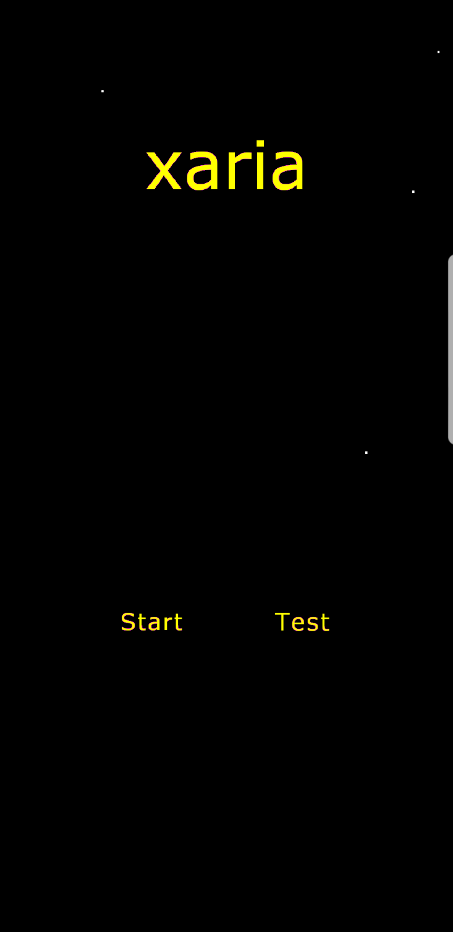

This is the testing screen. The user can see which tests were passed on the display. The user can also see which enemies are spawned at certain levels. To see a different level, the user taps the screen.

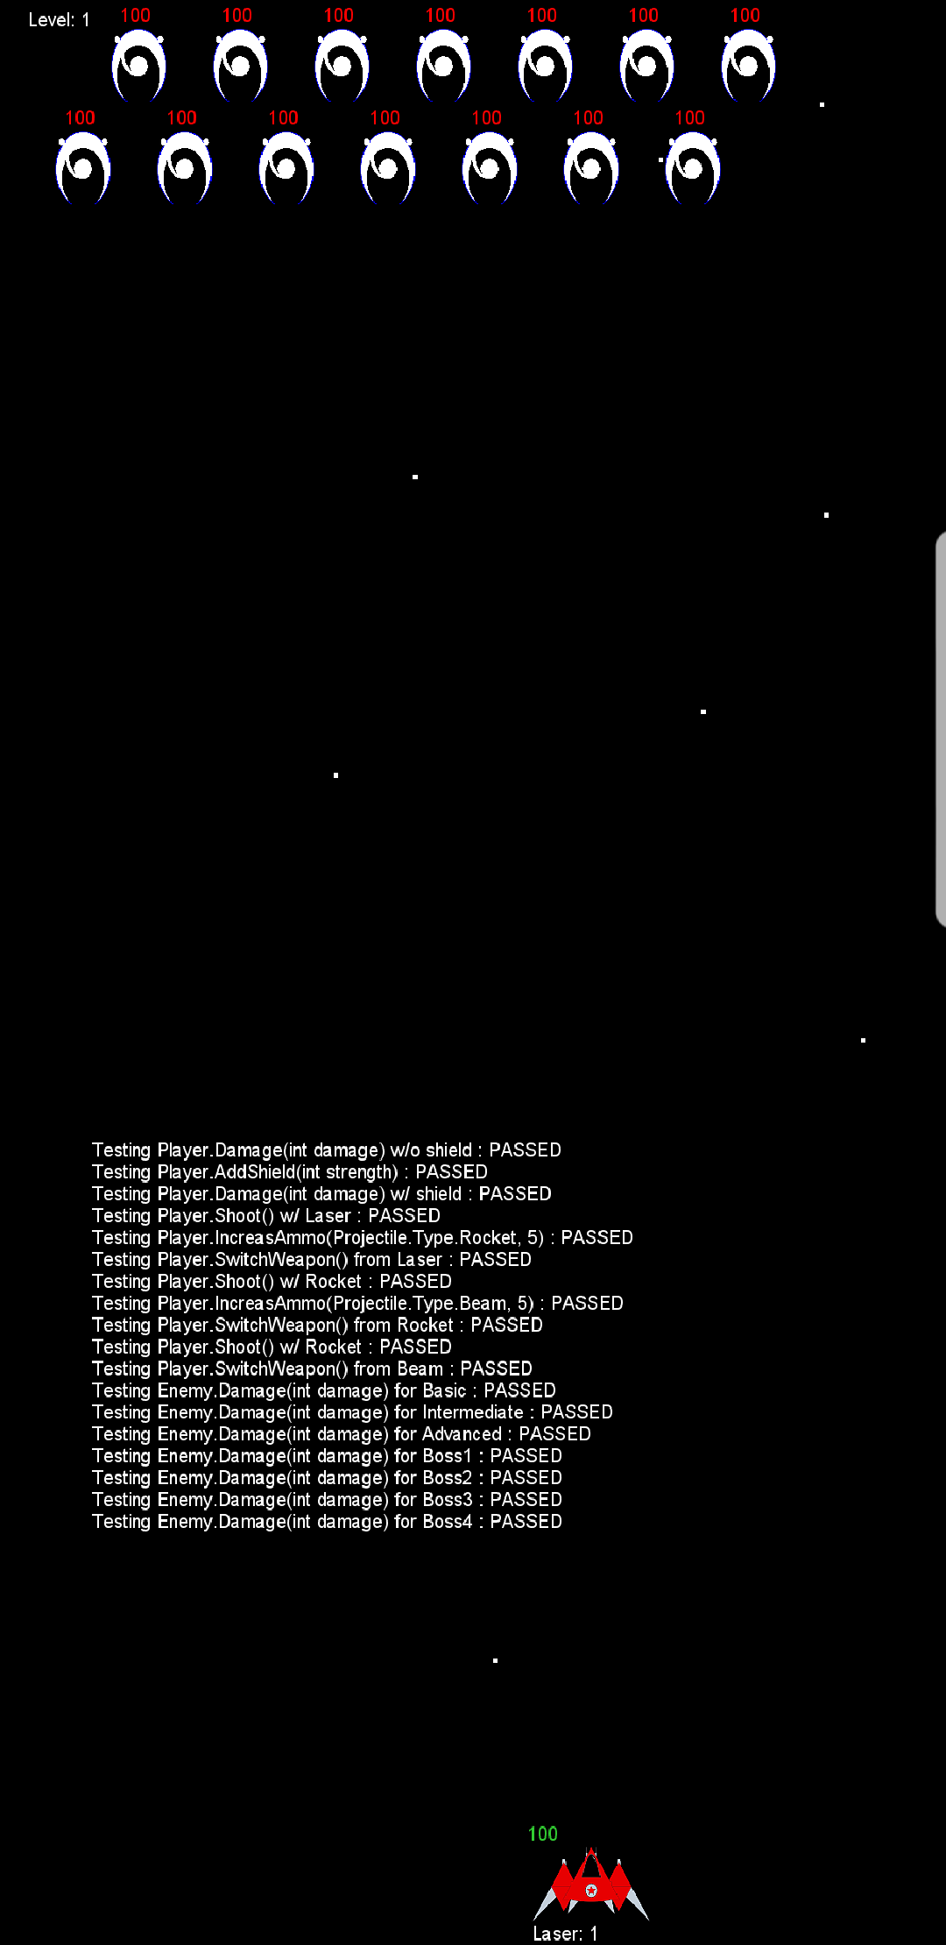

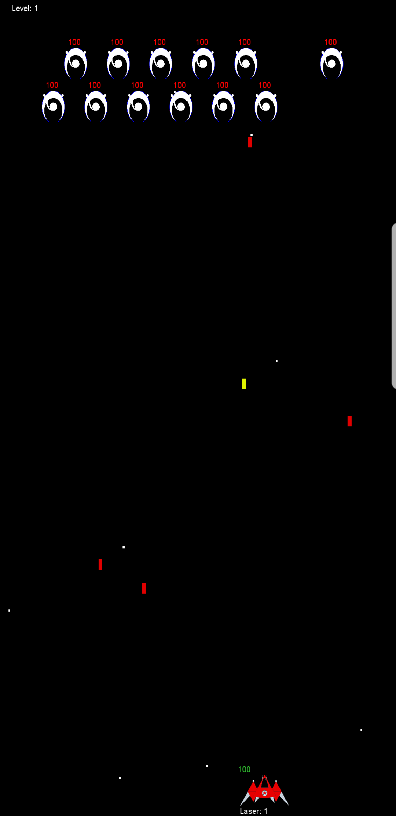This is the playing game screen. The user has two options of input: tapping the phone and tilting the phone parallel to the floor. Tilting the phone a larger amount causes the user’s ship to move faster in the direction of the tilt. Tapping on the phone shoots a projectile at the enemies. The user can gain new projectiles from enemies by killing them. To switch to a different player projectile, the user can tap on the player ship to scroll through the player-owned projectiles.

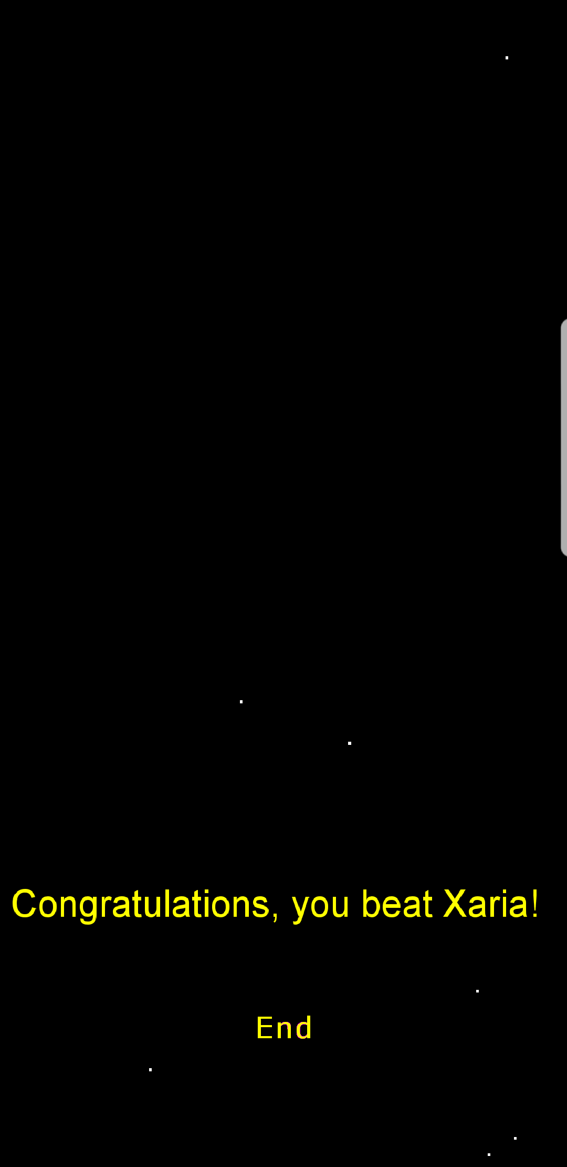If the user manages to beat Xaria, they will be greeted by this congratulations screen. Alternatively, if the user did not beat Xaria, the user will be greeted by a similar screen displaying which level they died on. To return to the main menu, press the end button.